

STUDENT NAME : LOGESHWARI M

PROJECT ID : 35

PROJECT TITLE : DC ENQUIRY FOLLOW UP AND NORMAL DC RELATED QUERIES

**TECHNICAL COMPONENTS**

| BACKEND | NODE.JS AND EXPRESS.JS |
| --- | --- |
| FRONTEND | Vue.js |
| DATABASE | MONGODB |
| API | REST FUL API |

**PROBLEM STATEMENT:**

Teams often face several challenges when it comes to project management, including:

**LACK OF CENTRALIZED MANAGEMENT:** Information and updates are scattered across different platforms, making it difficult to get a holistic view of the project status.

**INEFFICIENT COMMUNICATION:** Important communications and updates can get lost in emails or messaging apps, leading to miscommunication and delays.

**DIFFICULTY IN TRACKING PROGRESS:** Without a clear system for tracking task completion and project milestones, it is challenging to monitor progress and identify bottlenecks.

**ROLE AND RESPONSIBILITY CLARITY:** Team members may not have a clear understanding of their roles and responsibilities, leading to duplicated efforts or missed tasks.

**RESOURCE ALLOCATION ISSUES:** Ineffective allocation of resources can lead to overworked team members and underutilized skills, affecting productivity and morale.

**LACK OF ACCOUNTABILITY:** Without a transparent system, it’s difficult to hold team members accountable for their tasks and deadlines.

**PROJECT-FLOW:**

**Purpose:**

The purpose of this project is to create and track a collaborative platform using the MEVN stack (MongoDB, Express.js, Vue.js, Node.js). This platform will facilitate efficient project management and real-time collaboration among team members. It aims to streamline task assignment, progress tracking, and communication, ensuring project milestones are met on time. Ultimately, the project seeks to enhance productivity and team coordination through a robust, scalable, and user-friendly application.

**Scope:**

The scope of this project includes developing a web application for project management and collaboration using the MEVN stack (MongoDB, Express.js, Vue.js, Node.js). It will feature user authentication, task management, real-time updates, and team communication tools. The project will focus on implementing core functionalities and user interfaces, excluding advanced features like advanced analytics or third-party integrations.

**Business Context:**

In today’s fast-paced business environment, effective project management and seamless team collaboration are critical for success. This project aims to address these needs by creating a user-friendly MEVN stack application that enhances productivity and communication. By improving project tracking and task management, the platform will help businesses streamline operations and achieve their goals more efficiently.

**Consideration:**

1.Ease of Use:Ensure the app is simple and intuitive for users to navigate, providing a seamless user experience.

2.Security and Scalability:Ensure the app can scale efficiently with an increasing number of users while maintaining robust security measures to protect user data.

**Dependencies:**

1. Technical Dependencies:Utilize the MEVN stack components (MongoDB, Express.js, Vue.js, Node.js) and ensure compatibility among them for seamless integration and functionality.

2.External Libraries and Tools:Incorporate any additional libraries or tools needed for features like authentication, real-time updates, or UI components, and manage their integration properly.

**User persons:**

1.Project Manager: Oversees project tasks, timelines, and team performance.

2.Team Member: Completes tasks, updates progress, and collaborates with the team.

3.Administrator: Manages user accounts and application settings.

4.Client/Stakeholder: Reviews project status and provides high-level feedback.

**User stories:**

As a Project Manager,I want to assign tasks and track progress to keep the project on schedule.As a Team Member,I need to update my task status and communicate with the team to ensure smooth collaboration.As a Client/Stakeholder,I want to review updates and provide feedback to ensure the project meets my expectations.

**Functional requirements:**

1.User Authentication:The system must support user registration, login, and role-based access control.

2.Task Management:Users should be able to create, assign, update, and track tasks with deadlines and priorities.

3.Project Dashboard:Provide an overview of project progress,including task completion, milestones, and deadlines.

4.Real-Time Collaboration:Enable real-time communication and updates through chat, notifications, and activity feeds.

5.File Sharing:Allow users to upload, share, and manage project-related documents and files.

6.Reporting and Analytics:Generate reports on project progress, task completion, and team performance.

7.Admin Controls:Administrators should manage user accounts, configure settings, and monitor application usage.

8.Security:Implement measures to protect user data and ensure secure access to the application.

**FLOWCHART:**

**ADMIN INTERFACE:**

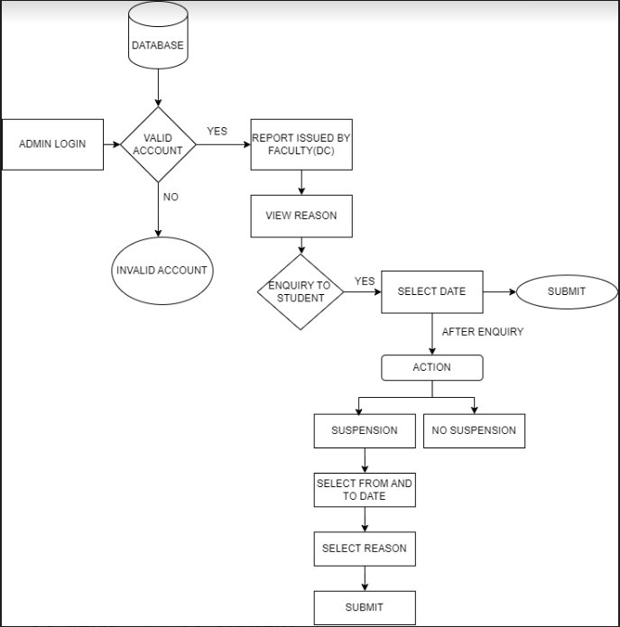

**FACULTY INTERFACE(DC)**

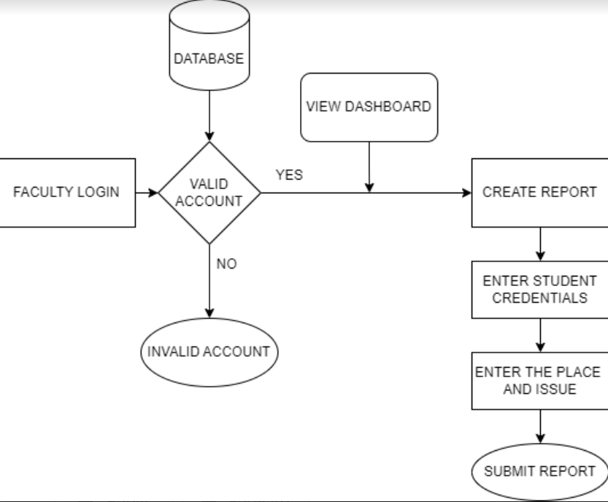

**STUDENT**

